

Sample Montly Report

April

2018

TABLE OF CONTENTS

1 INTRODUCTION 3
2 REMOTE IT SUPPORT 3
3 SERVERS UPTIME 3
4 ANTI VIRUS SOFTWARE 4
5 SERVER BACKUPS 4
6 MARSHAN TECHNOLOGIES RECOMMENDATIONS AND QUOTES 5

INTRODUCTION

Sautech (Pty) Ltd is currently the solutions and hosting partner of Marshan Technologies (Pty) Ltd. For the remainder of this document, the abbreviated names, Marshan Technologies will be used for Marshan Technologies (Pty) Ltd. And Sautech for Sautech Pty Ltd.
This document is the reporting document and will be distributed monthly to selected Marshan Technologies representatives.

REMOTE IT SUPPORT

During April 2018 the below helpdesk calls were logged:
Subject | Requester | Assigned To | Status | Created Date | ID
Kaspersky Encrytion to Bitlocker | Client | Dirk | Closed | 05/04/2018 | 70122
RE:Spam Quarantine Report | Client | Chandre | Closed | 09/04/2018 | 70229
Info Mailbox Access | Client | Sonet | Closed | 24/04/2018 | 70845
Delivery –Laptop Locks | Client | Dirk | Closed | 25/04/2018 | 70211
Delivery – Laptop +Bag and Mouse | Client | Dirk | Closed | 03/04/2018 | 69885
Backups and Anti Virus | Client | Dirk | Closed | 11/04/2018 | 69632
Forwarding Group | Client | Dirk | Closed | 03/04/2018 | 69869
Laptop Lock | Client | Chandre | Closed | 05/04/2018 | 70589
Add RDP Users | Client | Sonet | Closed | 17/04/2018 | 70589
Reinstall Ip Printer on Imac | Client | Lukas | Closed | 24/04/2018 | 70864

SERVERS UPTIME
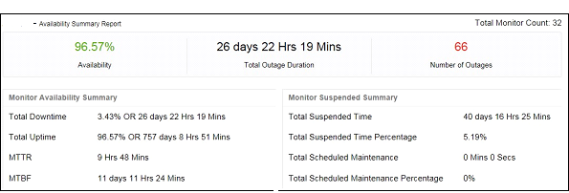
Outage Duration is due to Maintenance & Switch Change

ANTI VIRUS SOFTWARE

All Servers are installed with Kaspersky Endpoint Security 10 for Windows. Daily an Anti-Virus email log is sent to all relevant Marshan Technologies representatives.
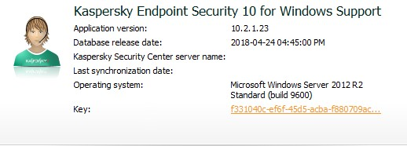

- License - License is in effect from 2018-01-23 until 2019-01-19
- Updates - Latest DB update was on 24-04-2018

SERVER BACKUPS

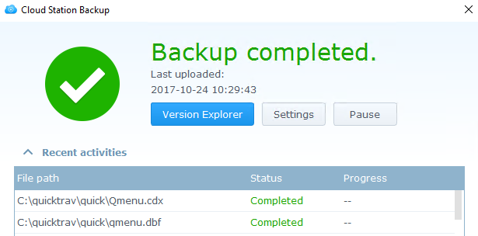

MARSHAN TECHNOLOGIES RECOMMENDATIONS AND QUOTES

It is recommended to perform the following functions and implemented the following changes on the Marshan Technologies Network, being, General, Internal, External or Hosted infrastructure

Description | Responsibility | Risk | Unit Cost | Notes | Status
Preventive maintaining has been done to Hyper-V server |  |  |  | Raid drive replacements

